**Experiment 2** – **Design Christmas dual LED chaser lights**

Circuit Diagram:

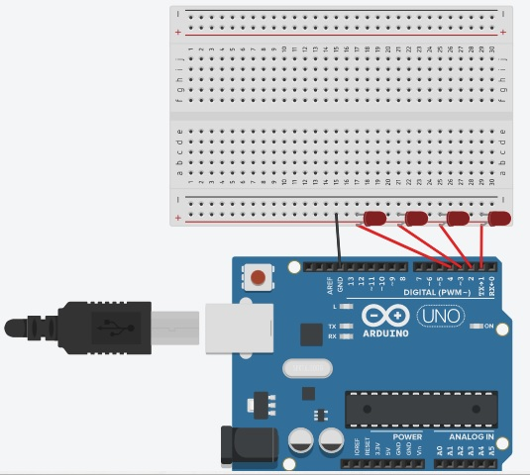

**Theory**

Concepts Used:

1. Working of Arduino UNO
2. Circuitry of Breadboard and it’s use
3. Coding in Arduino IDE and syntax of the same
4. Working of LEDs (Light emitting diodes)
5. Making connections on a Breadboard.
6. For loop syntax and use.

Learning & Observations:

Use of Arduino board and coding in Arduino IDE: Arduino board is very systematical way to show how the circuit is working. Coding syntax is this is similar to the coding in C language which we already know. I learnt the importance of delay function as the micro-controller is fast and capable.

I observed that there are many other interesting functions we can perform with Arduino like blinking of LED.

Problems & Troubleshooting:

I had to take many tries to find the right delay so that one LED at a time works turns ON and then gets OFF and this works like a strip.

Precautions

1. Remember to declare all the ports in use in digital input/output in the right way.
2. Check whether all your wire connections are correct and tight.
3. Remember to connect Negative end of device (in this case LED) to GND (ground) in Arduino Uno to ensure potential difference.
4. TRY to find right amount of delay by approximation and improvisation by trial so that the circuit performs at it’s best.

Learning Outcomes

Skills that I have acquired are more knowledge of using Arduino UNO and a better idea of approximation by trial.